Verification of Thevenin’s and Norton’s Theorem

LAB # 9&10



Spring 2022

CIRCUIT AND SYSTEMS 1 LAB

Submitted by: MUHAMMAD SADEEQ

Registration No.: 21PWCSE2028

Section: C

"On my honor, as student of University of Engineering and Technology, I have neither given nor received unauthorized assistance on this academic work.'

Submitted to:

Engr. Faiz Ullah

(16 June, 2022)

Department of Computer Systems Engineering University of Engineering and Technology, Peshawar

**Experiment # 9 & 10**

Verification of Thevenin’s and Norton’s Theorem

**Objectives:**

To verify Thevenin’s and Norton’s theorem on the simulation tool PSPICE

**Thevenin theorem:**

Thevenin's Theorem states that “Any linear circuit containing several voltages and resistances can be replaced by just one single voltage in series with a single resistance connected across the load.

Thevenin's theorem states that it is possible to simplify any linear circuit, irrespective of how complex it is, to an equivalent circuit with a single voltage source and a series resistance.

Thevenin's Theorem provides an easy method for analyzing power circuits, which typically have a load that changes value during the analysis process. This theorem provides an efficient way to calculate the voltage and current flowing across a load without having to recalculate your entire circuit over again.

**Norton’s Theorem:**

Norton's Theorem states that it is possible to simplify any linear circuit, no matter how connected to a load. complex, to an equivalent circuit with just a single current source and parallel resistance

Any linear circuit containing several energy sources and resistances can be replaced by a single Constant Current generator in parallel with a Single Resistor“.

It is used to reduce a complex circuit into a simple circuit. Norton's theorem is useful to solve problems on parallel generators with unequal emf's and unequal impedances. Norton's theorem can be interchangeably used with Thevenin’s theorem through proper source transformations.

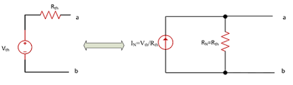

Thevenin and Norton equivalent circuits

**PSPICE Simulator:**

PSPICE is a computer-aided simulation program that enables you to design a circuit and then simulates the design on a computer. As this is one of its main purposes, it is used extensively by electronic design engineers for building a circuit and then testing out how that circuit will simulate

**Apparatus:**

➢ Computer with PSPICE software installed on it

**Procedure:**

1. Open schematic program of PSpice.
2. Click on the “Get New Part” button on the toolbar.
3. Type ‘r’ in the search bar and place the eight resistors on the white sheet.
4. Type ‘vdc’ in the search bar and place it on the white sheet.
5. Type ‘gnd-earth’ and place two of them on the white sheet.
6. Now arrange these components on the white sheet according to the circuit diagram as following.
7. After arranging click on simulate button and the following results are generated.

**In this lab we perform experiment to verify the Norton & Thevenin Theorem. Consider the following circuit for the verification of the theorem:**

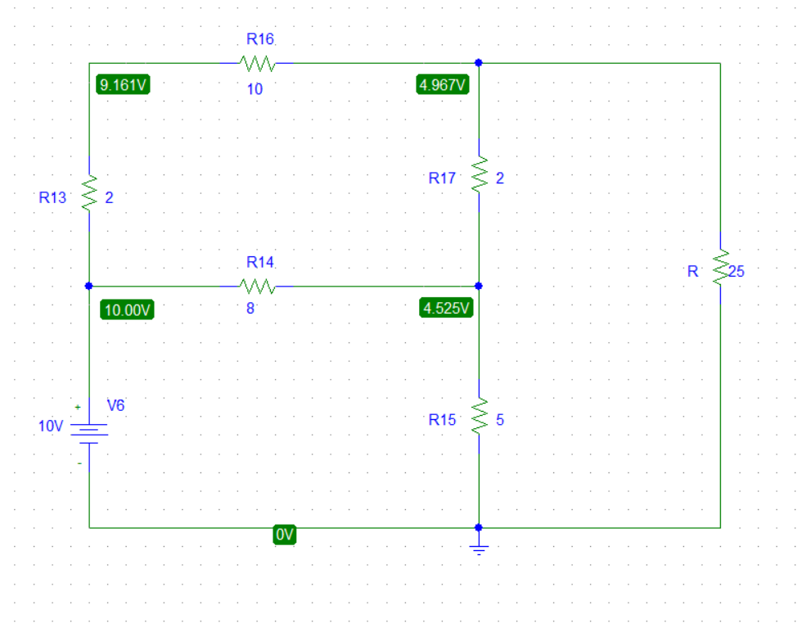

Figure 1

**In Norton & Thevenin Theorem we perform the following three steps:**

1. Remove the resistor R and leave the circuit open across R.
2. Remove the resistor R and join the wires across R to short the circuit.
3. Find which is given as:

**Finding Thevenin Resistance ():**

To find Thevenin Resistance () we have to first find the Isrc and Vth

**Finding : Vth**

To find we modify our circuit we removed the resistor R and leave the circuit open across R:

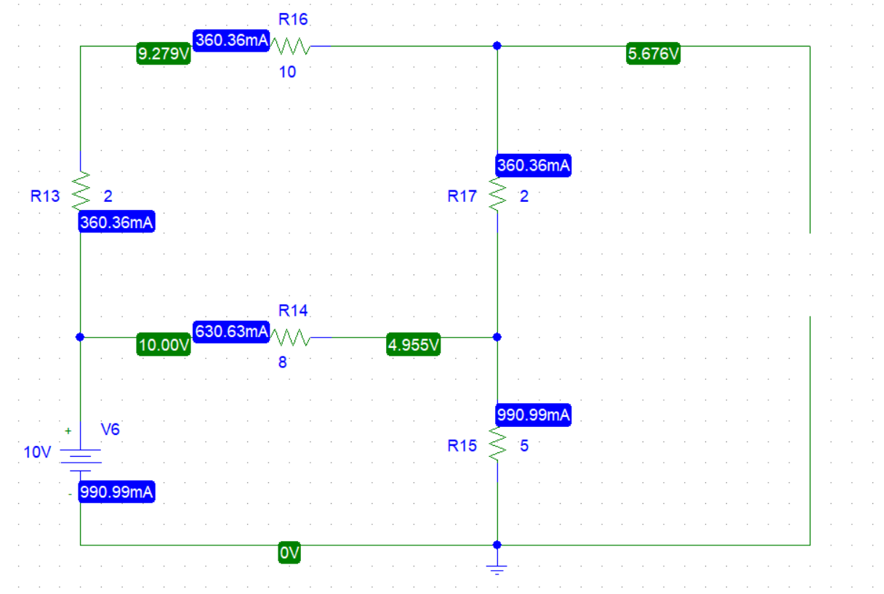

Figure 2

Now the voltage across R (which is now open) is the required i.e Vth

**Finding : Isrc**

To find we modify our circuit we removed the resistor R and join the wires across R to short the circuit:

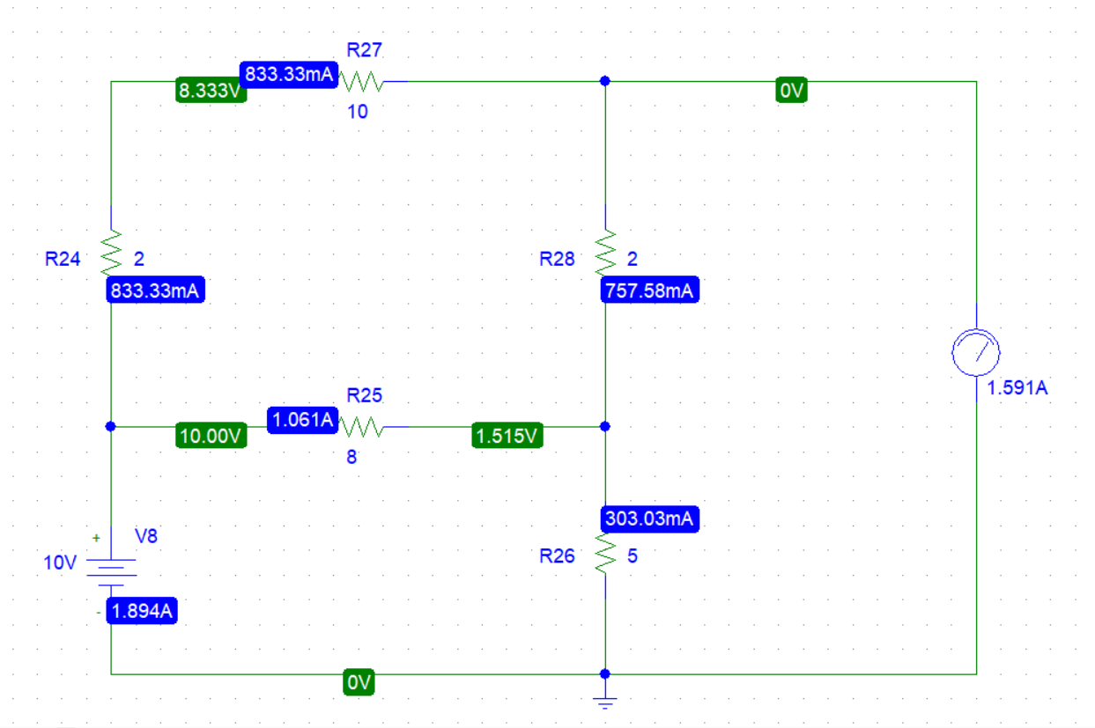

Figure 3

Now the current across R (which is now removed) is the required Isrc

Now we can find the Thevenin resistance using the given formula:

Rth = Vth / Isrc

**Now finding the Norton current :**

We can find the Norton current by using the formula:

Ith = Vth / Rth

Using these values of Norton current, Thevenin Resistance () & Thevenin voltage () we can perform source Transformation and can a simplified circuit that represents the whole big circuit.

**Source Transformation:**

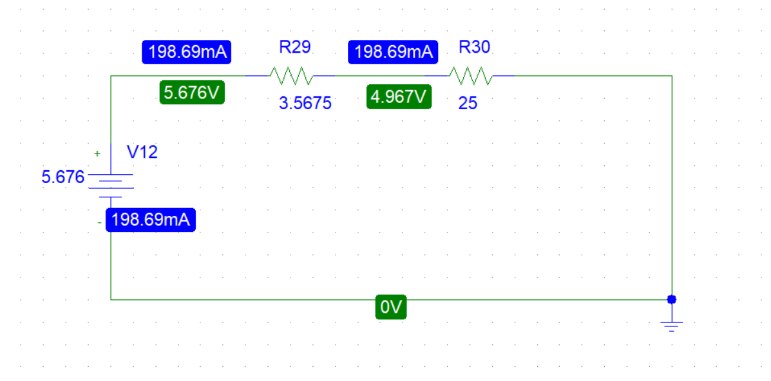

Figure 4

In the above circuit voltage source has a value of that of Vth and the resistor R29 has a value of that of Rth This circuit now represents the whole circuit given in Figure 1.

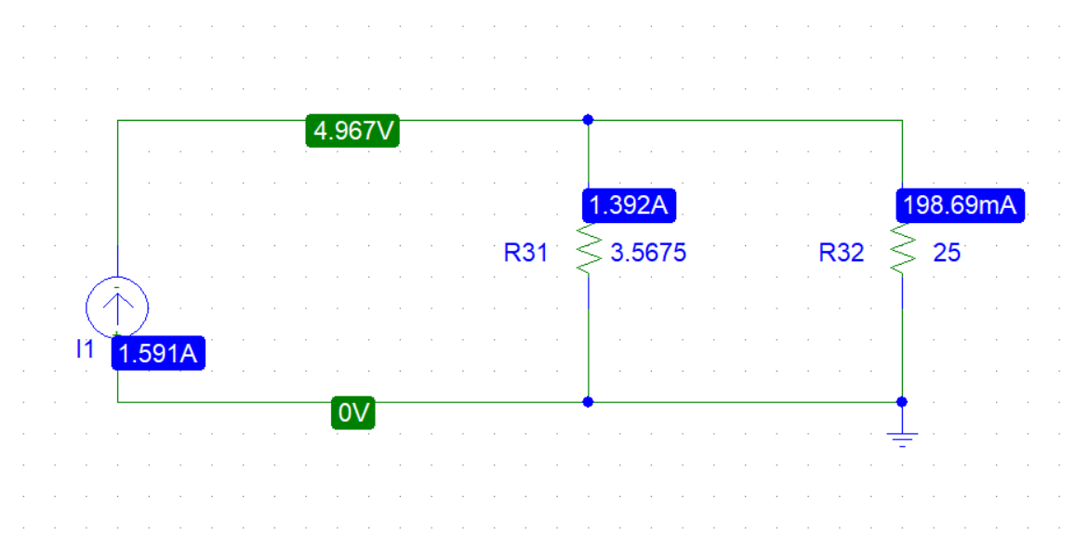

Figure 5

In the above circuit, a current source has a value of that of Ith, and the resistor R31 has a value of that of Rth This circuit now represents the whole circuit given in Figure 1.

**Conclusion:**

From the obtained reading I concluded that Norton's theorem affirms that any linear electrical circuit is equivalent to an ideal current source in parallel with an equivalent resistor and Thevenin's Theorem states that it is possible to simplify any linear circuit, no matter how complex, to an equivalent circuit with just a single voltage source and series resistance connected to a load.